THE STATE UNIVERSITY OF ZANZIBAR



SCHOOL OF COMPUTING, COMMUNICATION AND MEDIA STUDIES
DEPARTMENT OF COMPUTER SCIENCE AND INFORMATION
TECHNOLOGY

TITLE: IMPLEMENTATION DOCUMENT
PROJECT : PAINTNOVA-COLORLAB SYSTEM
COURSE:SOFTWARE DEVELOPMENT PROJECT

PARTICIPANTS: REG NO
ABDALLAH HORERA FADHIL 24BCS013
AMINA JUMA HAMAD 24BCS035
SHARIFA MOHAMMED ALI 24BCS007

Table of Contents
INTRODUCTION 3
Purpose 3
Scope 3
System Architecture 4
Presentation Layer (User Interface) 4
Business Logic Layer (Application Layer) 4
Data Access Layer (Storage Layer) 5
Key Modules 5
User Registration & Authentication Module 5
Product Management Module 5
Order Processing Module 6
Priority Queue Logic 7
Algorithm Analysis 7
Technology Stack 7
OUTPUT 8
Source Code 9
Output of Source Code 22

INTRODUCTION
PaintNova-ColorLab System is a role-based console application designed to manage products, users, and customer orders within an organization. The system controls inventory, processes customer orders through multiple approval stages, and enforces role-based access for Admin, Worker, and Finance departments. It provides structured workflow management including stock validation, order prioritization, approval, and final processing.

Purpose
The system aims to:
- Provide secure login and role-based access control (Admin, Worker, Finance)
- Manage product inventory including stock tracking and pricing
- Allow workers to create and manage customer orders
- Enable finance department to approve or reject orders
- Ensure stock safety protection before completing orders
- Maintain structured order processing workflow

Scope
The platform supports three primary user roles:
- Admin:
  - Register users
  - Add products
  - View products
- Worker:
  - Add customer orders
  - View orders
  - Process completed orders (reduce stock)
  - View products
- Finance:
  - View orders
  - Approve orders
  - Reject orders
  - Handle payment processing

System Architecture
The system follows a Three-Tier Architecture design pattern separating the application into logical layers.

Presentation Layer (User Interface)
Console-based terminal interface using menu-driven navigation:
- Login screen
- Admin menu
- Worker menu
- Finance menu
- Input prompts using printf and scanf
- Structured output display for products and orders

Business Logic Layer (Application Layer)
Contains core operational logic and workflow management:
- Authentication system (username/password validation)
- Role-based access control
- Product management (add, search, view)
- Order creation and priority handling
- Order approval and rejection
- Payment state management
- Stock validation and deduction
- Order processing and removal from list
Order Status Workflow:
- 0 → Pending
- 1 → Approved
- 2→ Completed
- -1 → Rejected

Data Access Layer (Storage Layer)
Data is stored in memory using static arrays and linked lists:
- Users → Stored in static array (max 50 users)
- Products → Stored in singly linked list
- Orders → Stored in singly linked list
Linked lists enable dynamic memory allocation for products and orders using heap memory.

Key Modules

User Registration & Authentication Module
- Admin initializes default account (admin / admin123)
- Users register with:
  - Username
  - Password
  - Role (1 Worker, 2 Finance, 3 Admin)
- Login validation uses string comparison
- Session stored using currentUser pointer

Product Management Module
- Add product with:
  - Product ID (auto-increment)
  - Name
  - Category
  - Stock
  - Price
- Products stored using singly linked list
- Product search using Linear Search
- View all products
- Time Complexity of search: O(n)

Order Processing Module
Workers create customer orders:
- Enter customer name and phone
- Select product by name
- Enter quantity
- System checks stock safety
- Assign priority:
  - VIP (1) → Insert at head
  - Normal (2) → Insert at tail (FIFO)
- Order receives unique ID
Finance Department:
- Approve pending orders
- Reject pending orders
- Mark approved orders as Paid
Worker Final Processing:
- Only Approved or Paid orders can be processed
- Stock is reduced
- Order removed from linked list
- Memory freed using free()

Priority Queue Logic
The order list acts as a priority queue:
- VIP orders inserted at head
- Normal orders inserted at tail
- Ensures VIP orders are handled first
- Maintains FIFO behavior for normal orders

Algorithm Analysis
- Linear Search used for:
  - Login validation
  - Product lookup
  - Order lookup
Time Complexity: O(n)
- Linked List Traversal used for:
  - Viewing products
  - Viewing orders
  - Processing orders
- Priority-based insertion:
  - Head insertion: O(1)
  - Tail insertion: O(n)

Technology Stack
- Language: C Programming
- Data Structures:
  - Static Arrays (Users)
  - Singly Linked Lists (Products, Orders)
- Memory Management: Dynamic memory allocation
- Libraries Used:
  - stdio.h – input/output
  - stdlib.h – malloc, free, exit
  - string.h – strcmp, strcpy
- Important Functions:
  - malloc() – allocate memory
  - free() – deallocate memory
  - strcmp() – string comparison
  - strcpy() – string copy
- Tools:
  - Compiler: GCC
  - Platform: Linux / Terminal
  - Interface: Console-based system

OUTPUT
The system produces structured console output including:
- Login success or failure messages
- User registration confirmation with unique ID
- Product addition confirmation
- Real-time product listing
- Order submission confirmation
- Order approval/rejection notifications
- Payment confirmation
- Order processing confirmation
- Stock validation and safety protection messages
The application maintains continuous execution using an infinite loop in main() until the user selects Exit, ensuring persistent session-based interaction.

Source Code
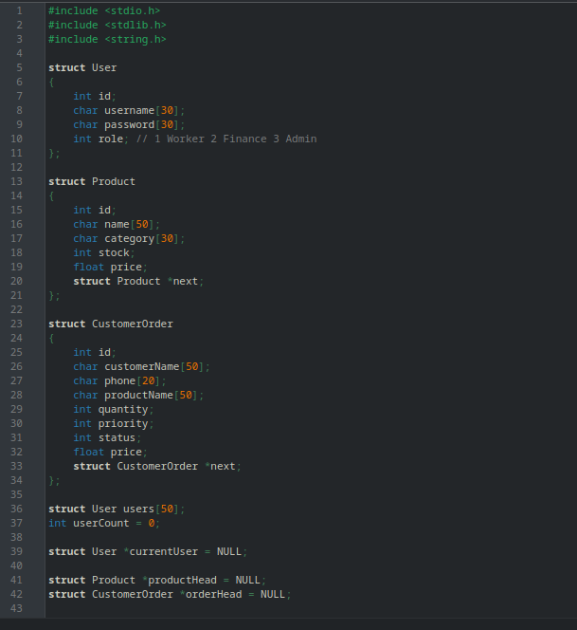
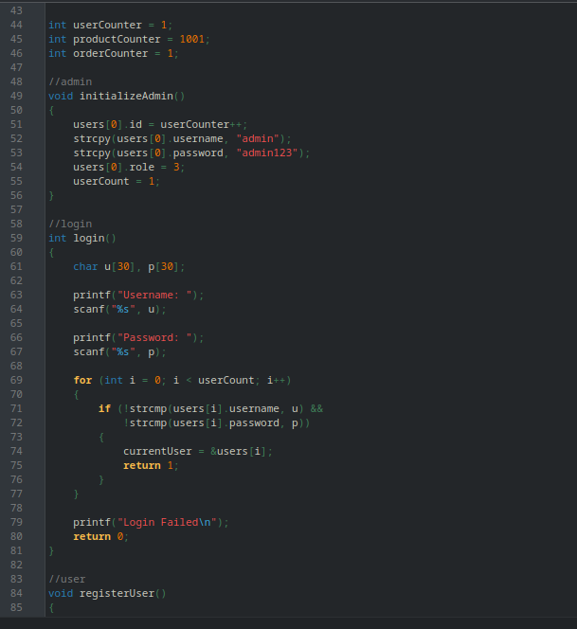
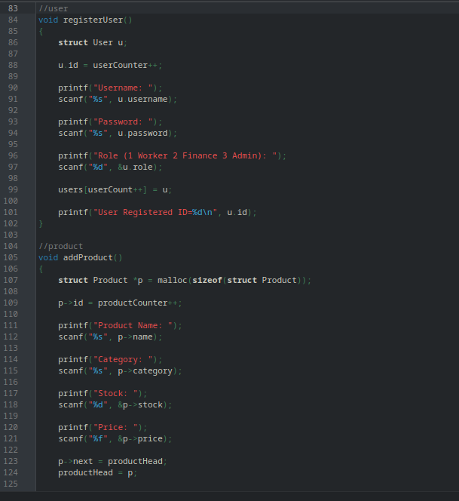
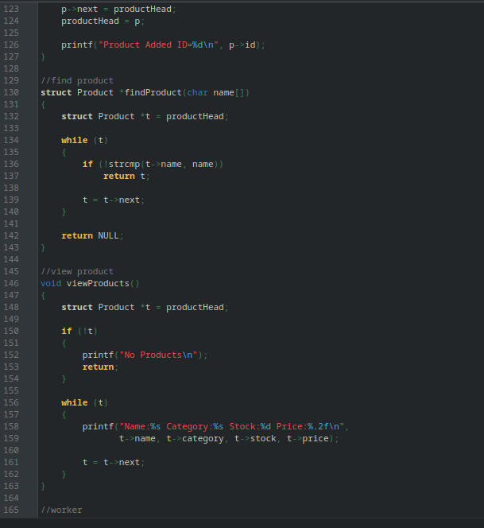
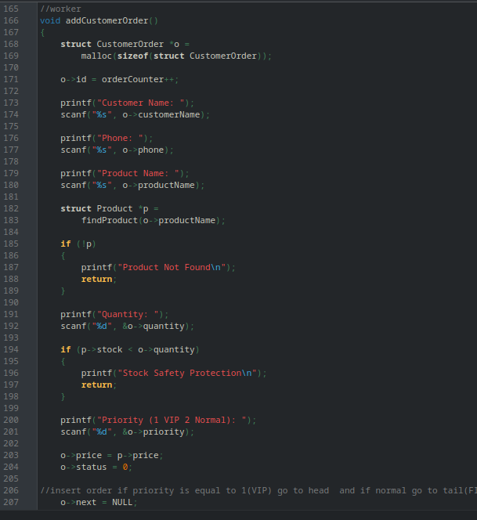
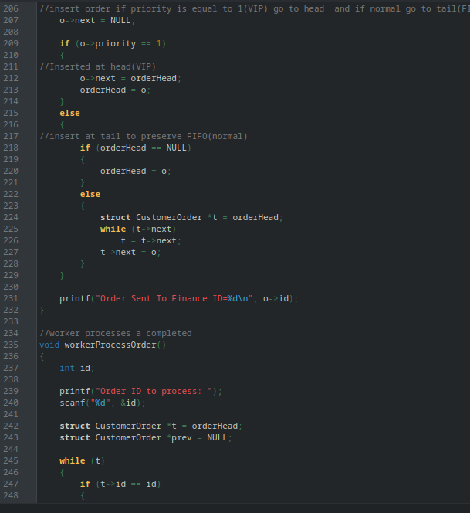
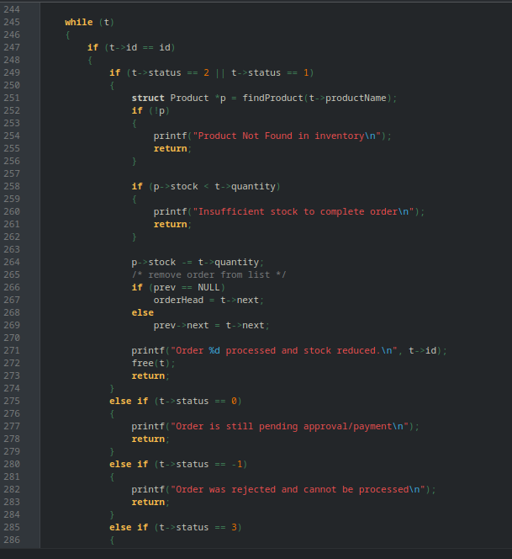
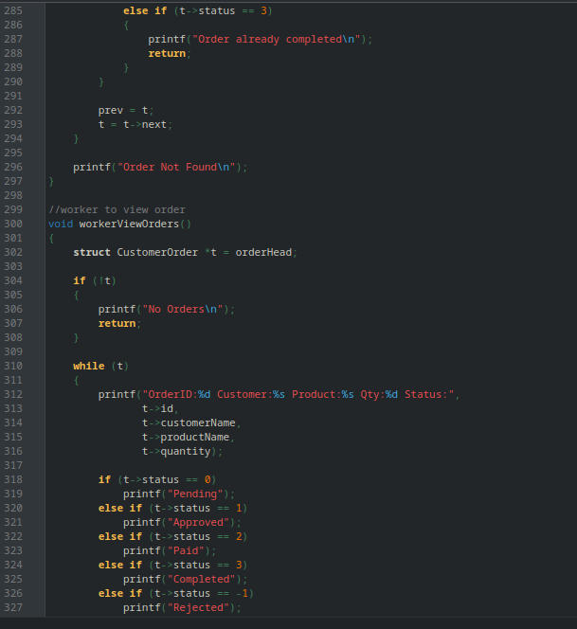
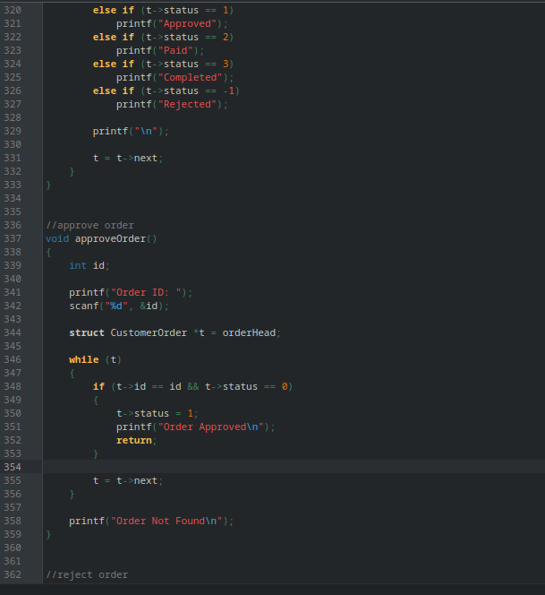
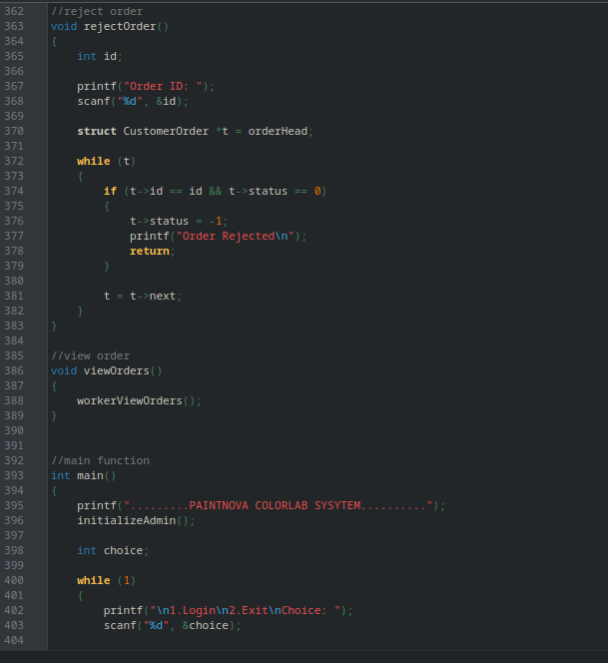
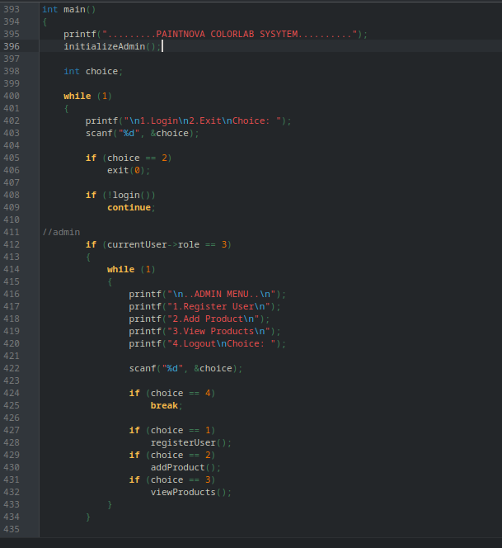
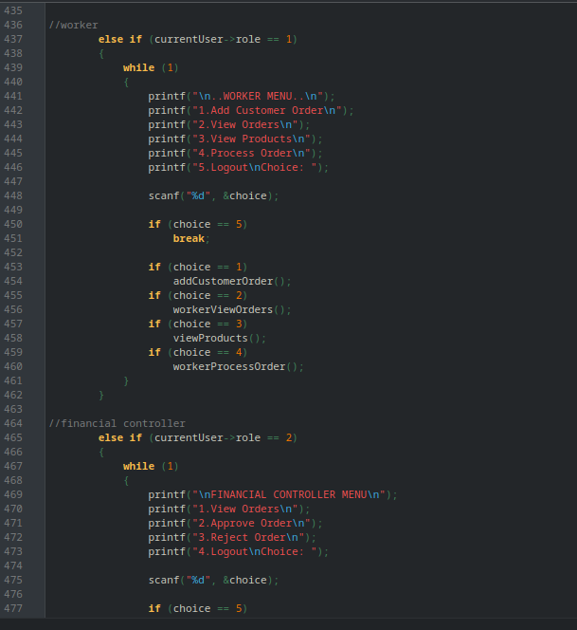
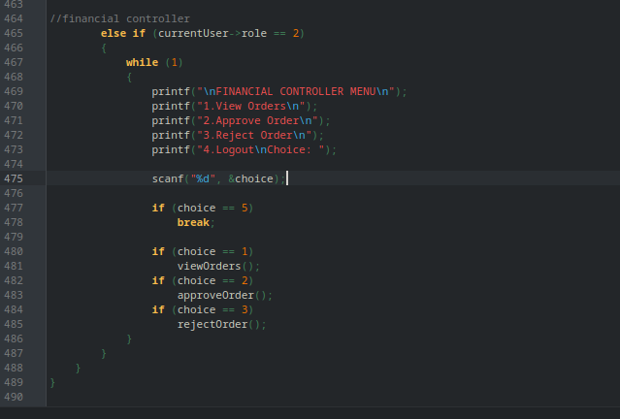

Output of Source Code

1. DIRECTOR

Admin(Director) login and register (worker and financial controller)

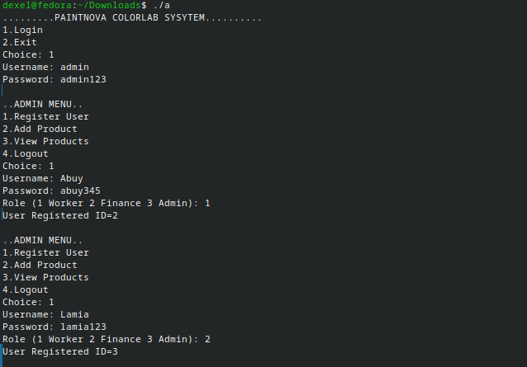
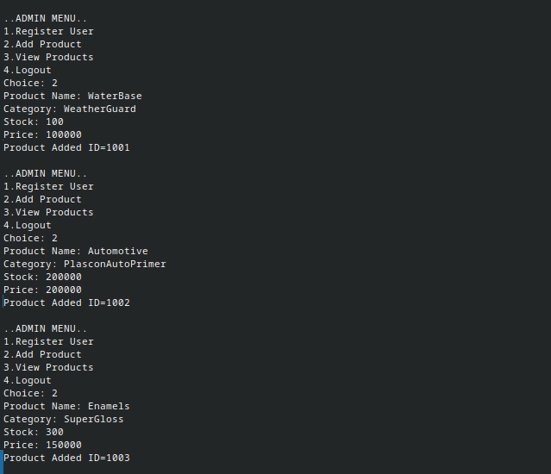
Add products
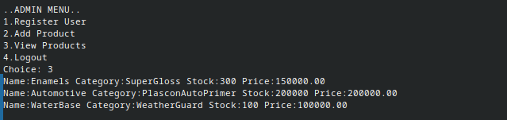
View products

2. WORKER

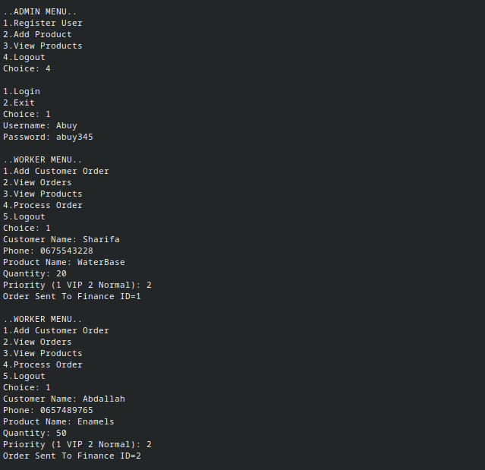
Worker login
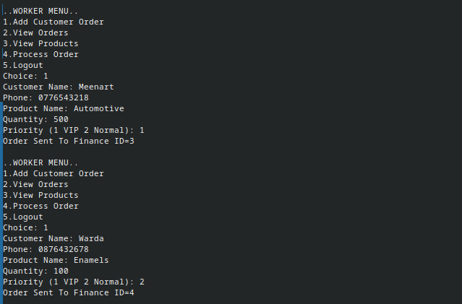
Add customer order

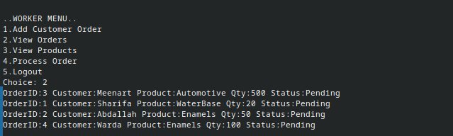
View order
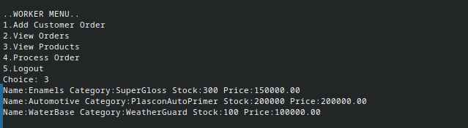
View products

Process order
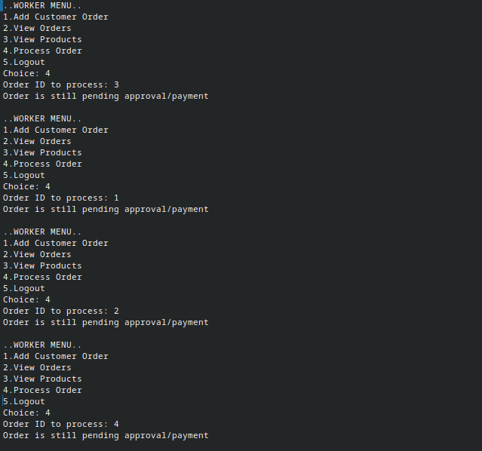
3. FINANCIAL

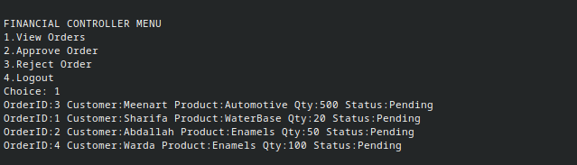
View orders

Approve order
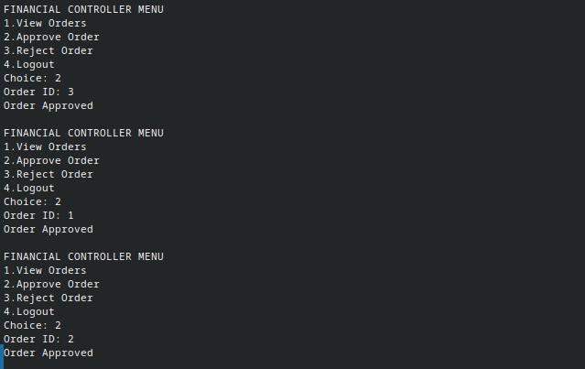
WORKER

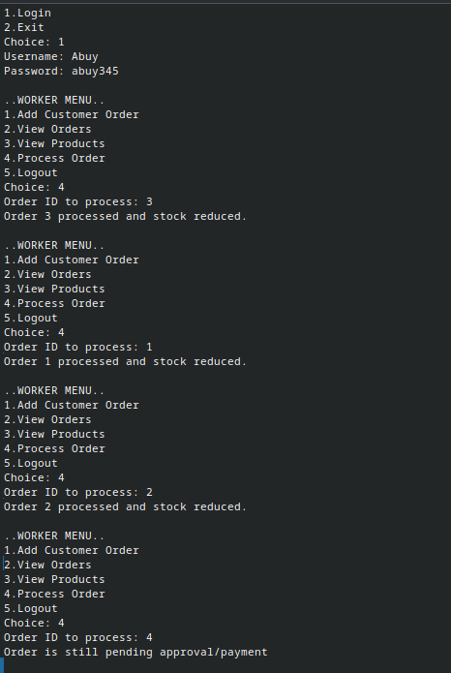
Process order again
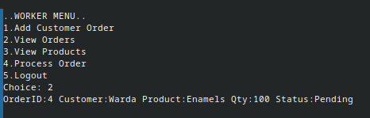
View remaining order

View remaning stock

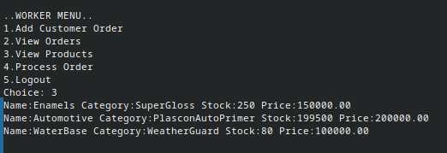

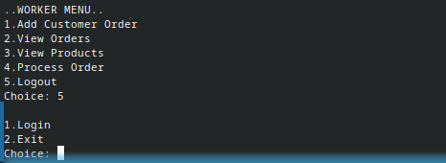
Log out

